Rapport etter mottatt studentstipend
Studentens navn | Malene Mathilde Mørkestøl
Tittel på oppgave | Cotaminant Levels in Turf Algae Along the Southern Coast of Norway: Environmental Conditions and Seasonal Variation
Beskrivelse | I forbindelse med en masteroppgave, ble stipendet brukt til å sende inn prøver av lurv til analyse av metaller og tinnforbindelser (til ALS laboratory group in Oslo). Sammendraget av oppgaven kommer her:  Sammendrag:  Turf algae blooms are an increasing environmental concern in coastal ecosystems, as they are leading to a uniform landscape dominated by turf, habitat loss, and thus lower biodiversity. In addition, heavy metal pollution and organotin compounds in the marine environment may pose harmful effects on marine organisms, ecosystems, and human health. Turf algae have also been suggested as a potential resource for agricultural fertilizers, making it important to consider their capacity for accumulation of pollutants.  The aim of this study was to investigate the extent to which turf algae accumulate metals and organotin compounds, and whether spatial and seasonal variations influence contamination levels. Turf samples were collected from three locations along the southern coast of Norway, with three stations sampled at each location. Two of the locations were sampled during both spring and autumn. Chemical analyses were conducted by an accredited laboratory, while statistical analyses, including PCA biplots, were performed in RStudio.  Overall, the results showed relatively low concentrations of metals and organotin compounds across most stations, with the exception of one marina station that appeared to represent a localized contamination hotspot. The marina stations generally  contained the highest concentrations of both metals and organotin compounds, whereas the one location without a marina displayed the lowest overall contamination levels. The heavy metal concentrations were generally higher during autumn compared  to spring. PCA analyses further indicated associations between certain metals and specific stations and seasons. The findings show that turf algae accumulate both metals and organotin compounds to  levels that could limit their suitability for agricultural applications such as fertilizer. However, the ability of turf algae to accumulate contaminants may also indicate a potential role in the removal of pollution from contaminated coastal environments.

Bilder | 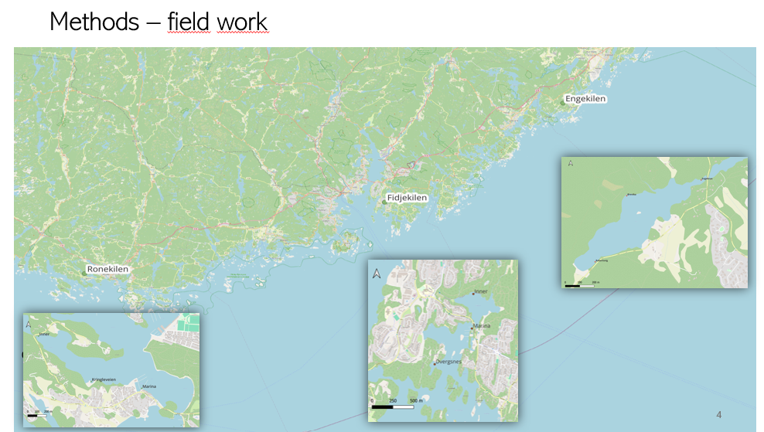  Stasjonene der lurvprøvene ble samlet inn vår og høst 2025  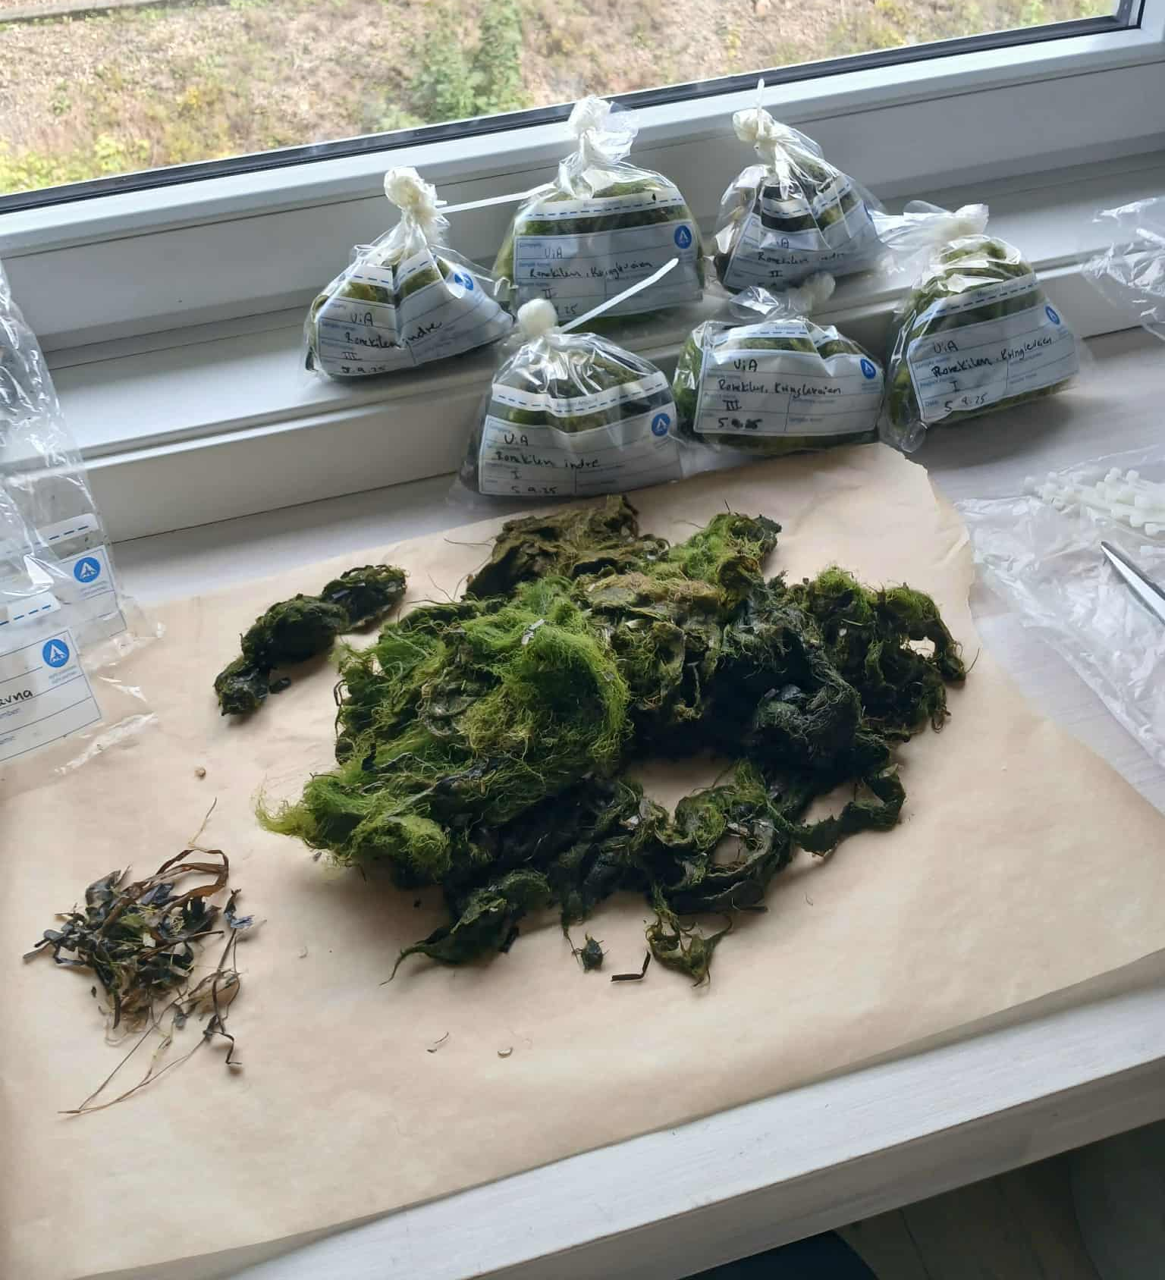  Noen av prøvene som ble sendt inn til laboratoriet  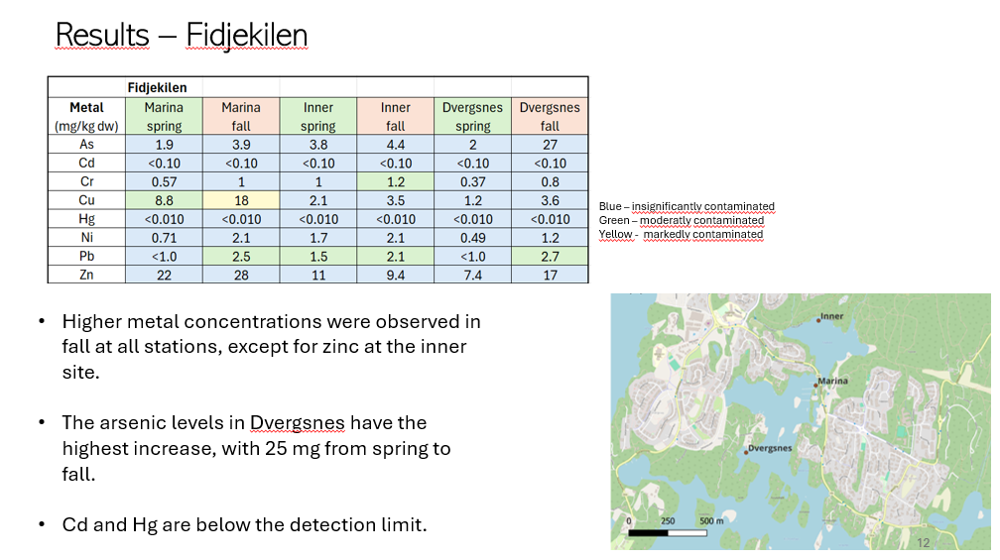  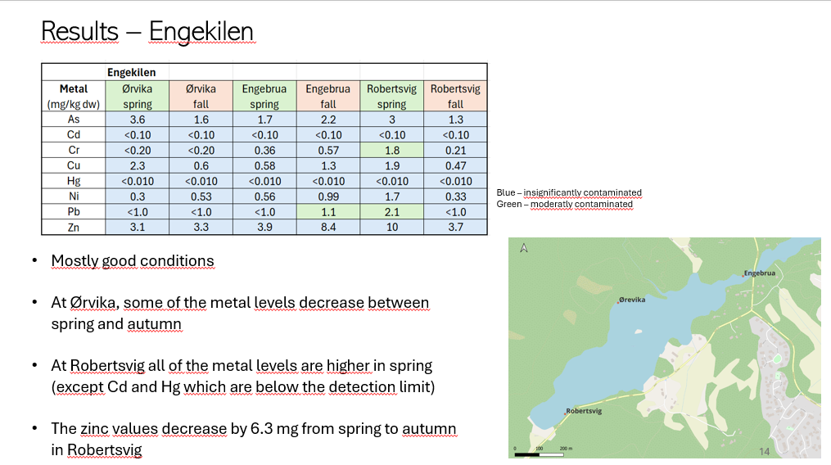  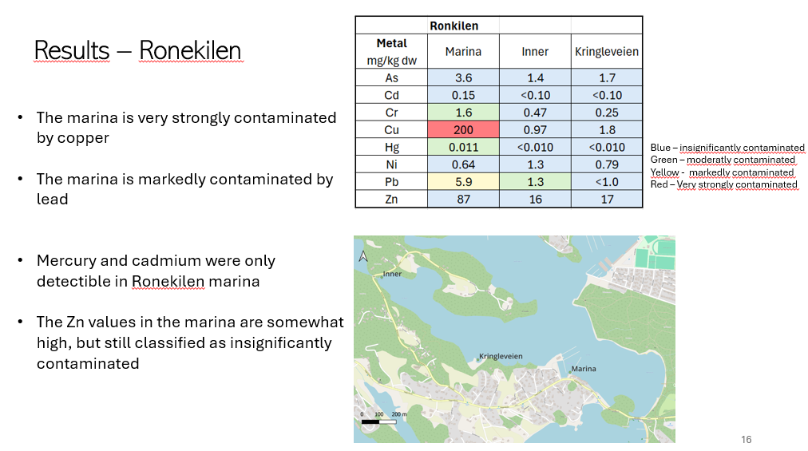  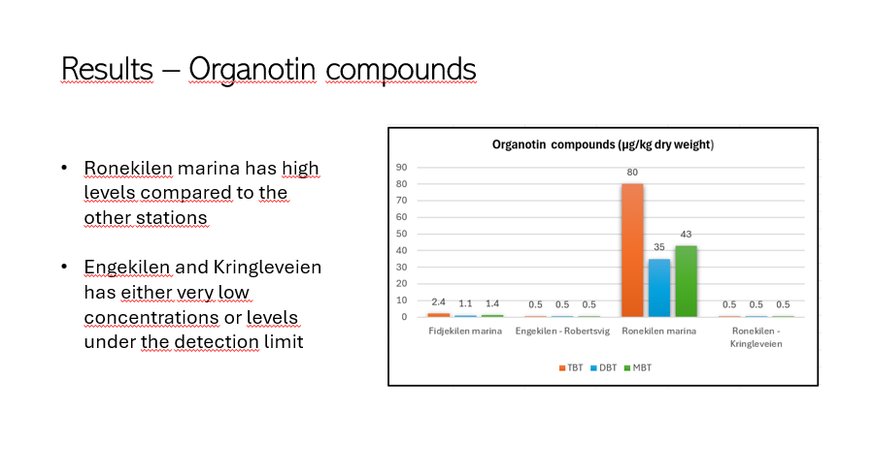  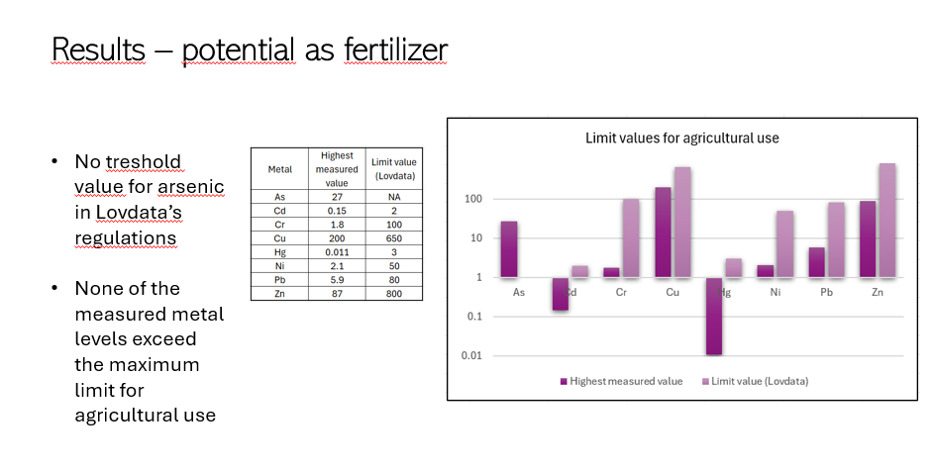  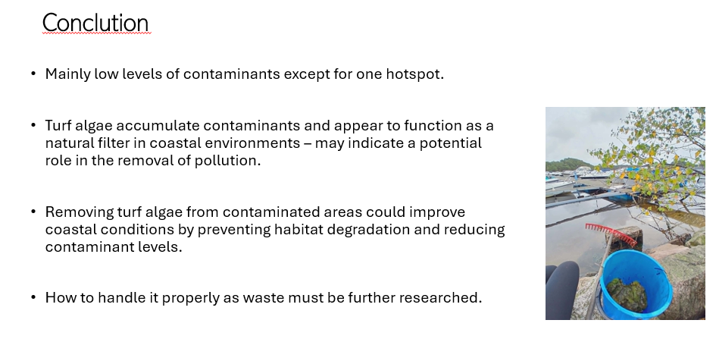

Bilder | <2-4 bilder, eventuelle figurer som beskriver aktiviteten.>

